**Android App for Text, Speech to sign language**

**Problem statement:**

* Communication between a deaf and dumb person with a normal person is almost impossible if either of them don’t know sign language
* This application will aid specially able people like deaf, dumb to communicate with normal person and vice versa.
* It helps them in such a way that it converts the text or speech into video sign language .

**Major Modules:**

* TEXT TO SIGN LANGUAGE

helps normal person to communicate with deaf and dumb person.

* SPEECH TO SIGN LANGUAGE

helps normal person to communicate with deaf and dumb.

* TEXT TO SPEECH(english)

helps dumb to communicate with normal person and blind.

**BLOCK DIAGRAM**

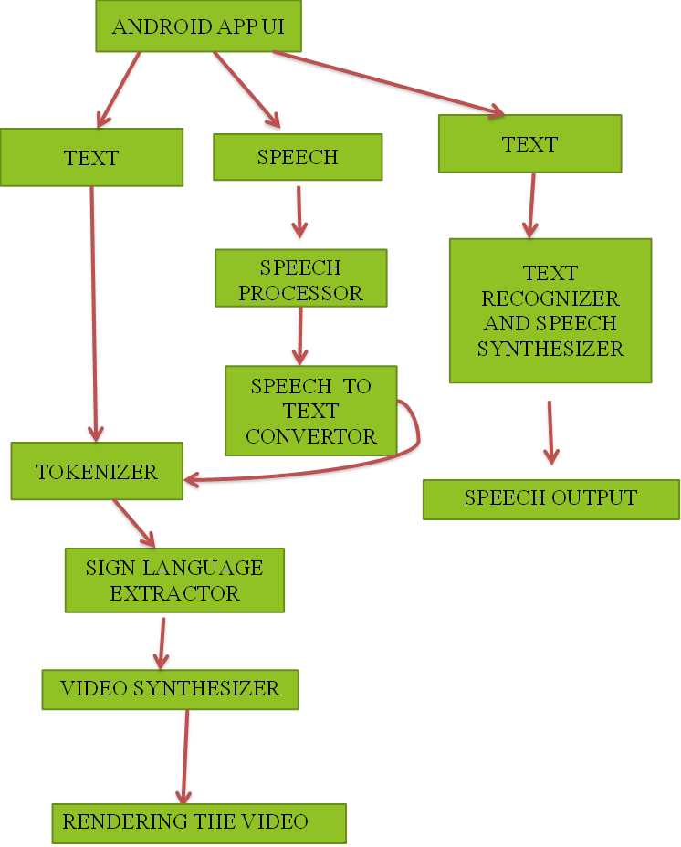

**Description :**

* **Speech Processor & Speech to text convertor:**
* The App invokes the speech recognizer API.
* The API recognizes the words spoken from the acoustic signal.
* The processing unit maps the acoustic sound of spoken words to the text dictionary and renders the text.
* **Tokenizer:**
* The text from the speech unit is split into tokens.
* Certain stop words from the extracted tokens are removed.
* The qualified tokens are then sent to the video synthesizer.
* **Video Synthesizer**:
* For each qualified token the corresponding “sign video” is extracted from database.
* Each video is run with the help of UI thread on the main application interface.
* **TEXT TO SPEECH CONVERTER**:

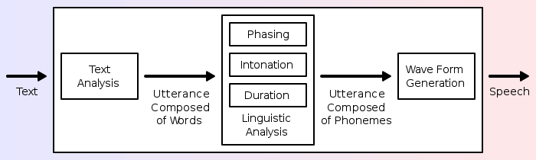

* TTS System is composed of two parts:
* front-end
* back-end.
* The front-end has two major tasks
* This process is often called *text normalization, pre-processing*, or *tokenization*. The front-end then assigns phonetic transcriptions to each word, and divides and marks the text into*prosodic units* (phrases, clauses, and sentences).
* The back-end—often referred to as the *synthesizer*—then converts the symbolic linguistic representation into sound